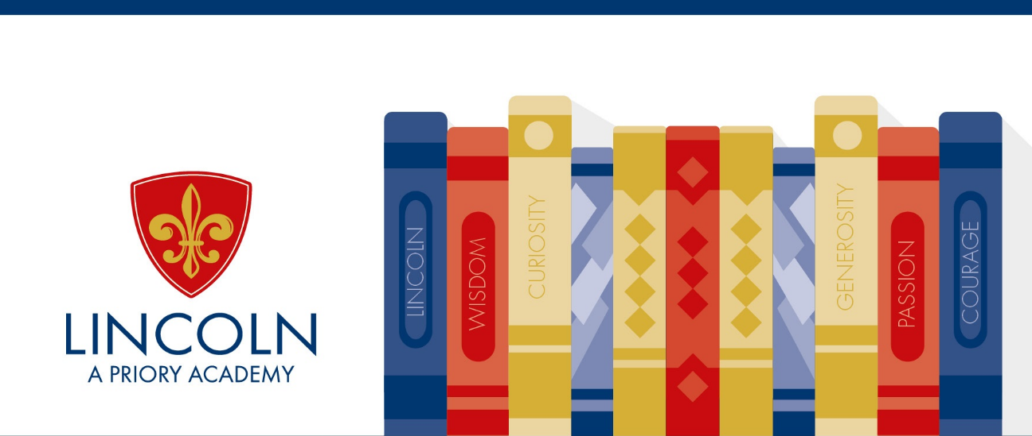
The Library is a welcoming environment where students can research, study and read for pleasure during lessons and in their spare time. Resources are available to borrow as well as for use in the Library.
Mrs Holland the Librarian is more than happy to help.
Opening Times Mon to Thurs 8.00am - 4.00pm Friday 8.00am - 3.30pm
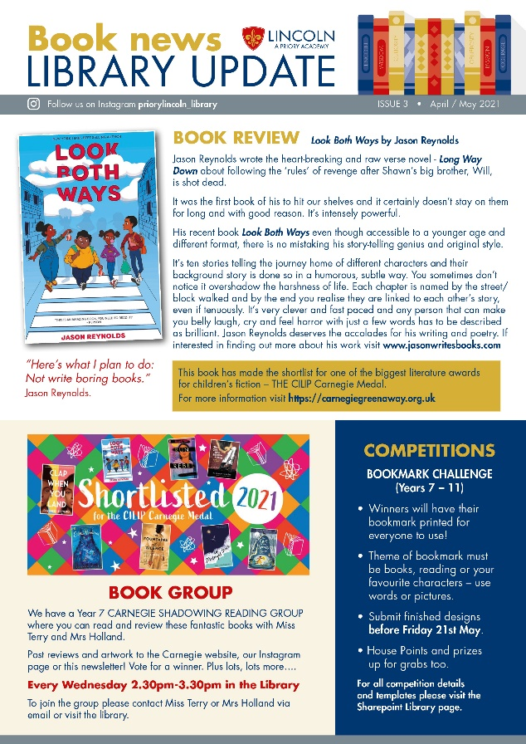
Resources and Facilities
Resources include fiction and non-fiction books, magazines, comics and reference materials. Study space is available, along with computer access, to enable you to carry out research or complete your homework. Or if you just want somewhere to relax and read a book then this is the place for you. Colourful displays advertise library resources, clubs, events and information.
In addition to clubs, the library runs competitions throughout the year. Book Club members have the opportunity to shadow the Carnegie Medal book award. We hope to have regular author events as well as other book related events like World Book Day and Harry Potter night.
Our Library Newsletter and the Library’s Instagram account @priorylincoln_library also shares up to date news and reviews.
Accelerated reader
Year 7 & 8 students participate in the Accelerated Reader programme which encourages and challenges them to read a wide range of fiction and non-fiction books. Personalised reading targets are set after an initial reading test and then students read their books and take online quizzes. Points are rewarded and students work in house teams to win prizes.

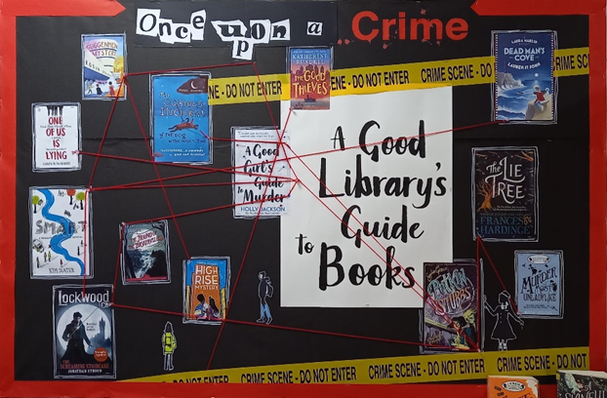
Our Library’s recommended reads for Year 7

A Kind of Spark by Elle McNicoll
Explorer by Katherine Rundell
The House With Chicken Legs by Sophie Anderson
The Shark Caller by Zillah Bethnell
Wonder by R. J. Palacio
The Boy At The Back Of The Class by Onjali Q. Rauf
Ghost Boy by Jewell Parker Rhodes
Storm Breaker by Antony Horowitz
After The War by Tom Palmer
Northern Lights by Philip Pullman
Look Both Ways by Jason Reynolds

Clap When You Land by Elizabeth Acevedo
Artemis Fowl by Eoin Colfer
No One is too Small to make a Difference by Greta Thunberg

FREE access to books, activities and videos can be found on the following:
https://tompalmer.co.uk/free-reads/
https://www.thenational.academy/library
https://www.barringtonstoke.co.uk/
https://authorfy.com/
https://www.lovereading4kids.co.uk/ https://www.worldbookday.com/online-masterclasses/

