British Values
I have the freedom to make choices that affect me but I recognise I am accountable for my actions.
.
I understand that Academy rules are used to mirror society laws and must be respected.
I recognise there will be consequences for my actions.
I recognise that it is unacceptable to dismiss the beliefs and opinions of anyone.
I understand that discussions on sensitive issues will be controlled and structured.
Individual Liberty

Tolerance
Rule of law

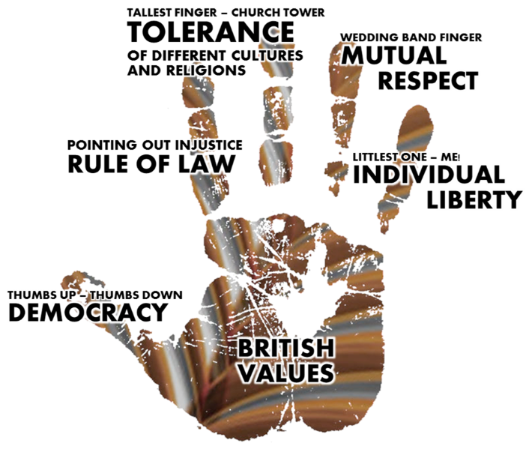
I influence my lessons through putting my hand up and responding.
.
Mutual Respect
Democracy
I recognise everyone is entitled to their opinion as long as it does not promote extremism.
I will listen to others as I would like to be listened to.

